2019 Global Study Visit Program
Costa Rica
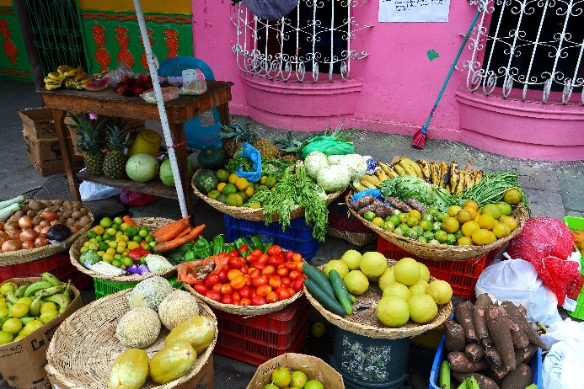
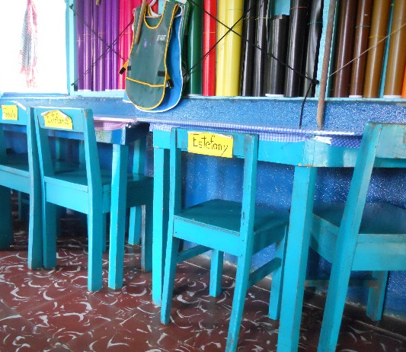
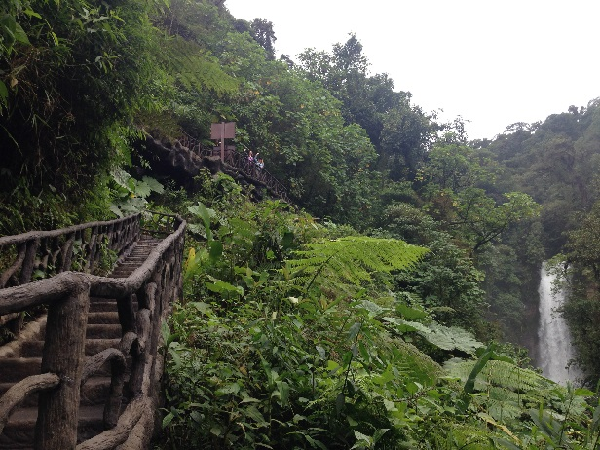

March through October 2019
Program includes: In partnership with
- Seminar and Orientation
- 10-day Study Visit to Costa Rica
- Program materials including book
and additional print and digital resources
- Post Study Visit Workshop

Travel dates to Costa Rica are
July 17-26, 2019

For more information contact:
Julie Kinnaird, World View
kinnaird@unc.edu or 919/962-6785

worldview.unc.edu/professional/global-study-visits
APPLICATION PERIOD CLOSES JANUARY 11, 2019 OR WHEN FILLED
World View’s 2019 Costa Rica Global Study Visit Program

World View’s Global Study Visit Programs are designed to support K-12 and community college educators in becoming leaders for global education by looking beyond the borders of North Carolina. Educators will experience a culture, country and community different from their own to deepen their learning about a country and the diverse factors impacting education. The global study visit program engages educators in authentic, experiential and challenging professional development opportunities to enhance educators’ personal and professional global competency skills.

This program begins with a two-day professional development seminar that will focus on learning about Latin America and the connections it has to North Carolina, including the state’s immigrant and U.S.-born Latinx populations. There will also be an afternoon orientation focused on travelling internationally, specifically for the study visit to Costa Rica. There will be additional web-based opportunities and resources provided to deepen educators’ knowledge of the issues and the culture of Costa Rica. Upon return from travelling to Costa Rica, study visit participants will take part in a post study visit workshop to reflect and develop a plan of action for integrating the experience into participants’ classrooms, schools and community colleges.

Educators who participate in the Costa Rica Global Study Visit Program can expect to do the following:
- Build their own global competencies as they investigate global issues, recognize their own perspectives and learn from and with individuals with different perspectives, communicate across cultures and take action by transferring a study visit experience into their own role as an educator.
- Increase their own confidence and capacity for introducing global issues and themes and supporting global education initiatives in their education environment.
- Exercise collaboration and leadership skills by working with others, moving outside of their comfort zones to be flexible and adaptable, engaging in critical self-reflection and planning follow-up steps.
- Increase their knowledge and understanding of culture, language and daily life in Costa Rica.
- Gain knowledge of Costa Rica’s educational systems and practices by visiting schools and engaging in round table discussions with educators, families and students.
- Explore Costa Rica’s ecological sites and increase knowledge of sustainable agricultural practices and how these practices impact families in Costa Rica.
- Gain empathy and understating for Latinx students in the United States who may be faced with multifaceted barriers or challenges.
- Design and share a “deliverable” that enables transfer of this powerful global experience back to the participant’s school or community college.
    - Deliverables can take a variety of forms: a globally integrated unit, a PD workshop for peers, a culture kit and learning guide to be shared with a grade level team, a community college globalized course module, incorporation into a Global Educator Digital Badge PD Capstone, a global education action plan, etc.
- Produce at least one reflection on the study visit experience to be shared with World View. This reflection can take a variety of forms and can be produced during or after the study visit. Examples include a photo essay, a brief article, a story map, blog posts, an audio diary, etc.

Study Visit Itinerary Highlights
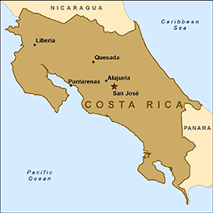
Costa Rica is a small country in Central America, bordering both the Caribbean Sea and the North Pacific Ocean, between Nicaragua and Panama. With five million people and over 51,000 square kilometers the country has a large agricultural sector, but is growing in the areas of both technology and tourism. Approximately one-fifth of the country’s population lives in the capital, San Jose. World View and Immersion Abroad Costa Rica take pride in creating the most authentic global experience that will forever influence the way educators live, work and communicate in today’s interconnected world. The itinerary is subject to change.

WEDNESDAY, JULY 17, 2019
BIENVENIDOS! Welcome to Costa Rica! Our Immersion Abroad Costa Rica (IACR) leaders will meet us at the San Jose airport where we will transfer to Atenas. Atenas is famous for having one of the best climates in the world, according to National Geographic. On arrival in Atenas, we will enjoy a delicious welcome lunch followed by a detailed orientation on what to expect throughout our journey and how to best prepare for our unique host family experience. Your host family will pick you up this afternoon to enjoy a relaxing evening with your new Costa Rican familia.

THURSDAY, JULY 18, 2019
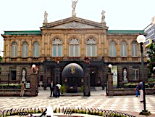
We’ll take a short but practical Spanish class, learning the basics to be able to communicate with our host families and for getting around town. In the late morning we will travel to the capital city of San Jose for a guided tour to the National Congress. World renowned as one of the strongest democracies in the world without a military, our tour will provide insights into Costa Rica’s unique history, cultural influences and determined leadership. We will visit the famous National Theater, an important place in the heart and history of the country. Furnished with priceless paintings, sculptures and period lamps and furniture, the theater attracts famous local and international artists eager to perform within its exquisite walls. We will end our day with a visit to the new artisan market, full of arts and crafts made by Costa Rican artisans.
FRIDAY, JULY 19, 2019
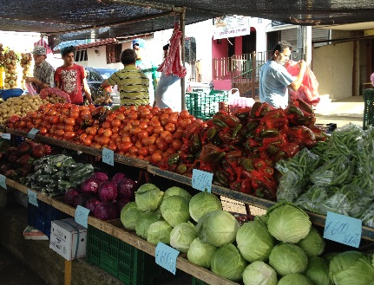
Prepare for a colorful and delicious morning as we explore the farmer’s market in the heart of Atenas. Joined by local Costa Rican students, we will have a chance to purchase and sample some of the most exquisite tropical fruits. From there we will get to know the quaint and friendly town of Atenas with a guided orientation activity. After touring Atenas we will learn about the Costa Rican education system while working with Colegio Bilingüe de Palmares / Bachillerato Internacional (IB school-10th and 11th grades). This school educates bilingual youth to be engaged critical thinkers who will be leaders in Costa Rica’s future. The afternoon will be dedicated to a discussion forum with local teachers reflecting on a variety of challenges and opportunities in education. Local teachers will also have time to ask questions about American education and classroom routines.

SATURDAY, JULY 20, 2019
This morning we will visit the Ark Botanical Gardens and Meadery where we will sample delicious artisanal honey and goat cheese with local homemade bread and hibiscus mead. The garden boasts one of the most comprehensive collections of medicinal and aromatic herbs, plants and trees from around the world. We will continue the day with a drive to the Peace Waterfall Gardens to explore some of the most beautiful and famous waterfalls in Costa Rica. We will have time to walk around the wildlife rescue preserve, home to over 100 species of animals. This evening we will participate in a Latin dance workshop! Learn to dance merengue, salsa, bachata and cumbia for a better understanding of Costa Rica’s rhythmic culture.

SUNDAY, JULY 21, 2019
Prepare for a great day of learning and fun as we celebrate family traditions. Today’s event will incorporate participation from homestay families as they jointly share the culturally rich traditions, games, stories and foods connected to their daily lives. We’ll also invite students from the National Institute of Learning (INA) to share their experiences and educational and career aspirations as young adults (17 to 22 years old).

MONDAY, JULY 22, 2019
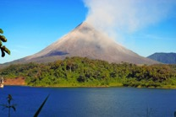
After saying good bye to our host families and friends, we’ll start our journey to the cloud and rain forest to the north. Costa Rica is well known for its volcanic activity. With six active and two highly active volcanoes, Costa Rica takes pride in collecting and providing geothermal power throughout the country. This morning we’ll witness the majesty of Arenal Volcano, located in the town of La Fortuna in the central northern part of Costa Rica. Participants will have a chance to walk around the tranquil and picturesque town. In the late afternoon and early evening we will experience the therapeutic hot spring waters at one of the most impressive lookout points of the volcano.

TUESDAY, JULY 23, 2019
Today begins our adventure to the Sarapiqui region on the Caribbean side of Costa Rica. Sarapiqui is one of the most biologically diverse regions in Costa Rica. Despite challenges in deforestation, Sarapiqui still contains some of the best-preserved cloud rainforests in the country. After checking in to our hotel we will tour an organic pineapple plantation, tasting pineapple and different products made with this delicious fruit. Learn about the harvesting of this fruit, the foreign workers who make this mass production possible and the final exportation process. No Costa Rican experience is complete without a chocolate tour in the rainforest. Get to know Costa Rica’s ancient chocolate currency, the “cacao fruit,” and its impact on the country’s history and commerce. We will experience the artisanal process by which the cacao fruit is transformed into chocolate, and of course we will sample different kinds of chocolate made on site! This afternoon we’ll return to our hotel in La Fortuna.

WEDNESDAY, JULY 24, 2019
After breakfast, we’ll head back to Atenas. On the way back, we will stop at the picturesque town of San Ramon (known as the Town of Poets) to visit and share with community members of La Asociación Mujeres Unidas en Salud y Desarrollo (MUSADE). MUSADE is a community-based non-profit providing a safe space for women in the community. MUSADE promotes equality and empowerment of women through job development and other social services. We’ll have the chance to visit one of the projects they have developed. After our visit in San Ramon we will head back and check in to our hotel in Atenas.

THURSDAY, JULY 25, 2019
This morning we will visit a local elementary school to continue exploring education in Costa Rica. In the afternoon we will unwind with a scenic drive to Herradura Beach where we will have a chance to swim, collect shells or just stroll along the warm tropical sands that hug the Pacific waters. On the way back to Atenas, we’ll stop to view native crocodiles on the bridge over the Tarcoles River. This evening we will enjoy a final meal together and share reflections on our incredible learning adventure.

FRIDAY, JULY 26, 2019
Today we will say farewell to new friends and Costa Rica and travel back to North Carolina. Our Immersion Abroad Costa Rica team will transfer us to the San Jose International Airport and we will begin our journey home.

Study Visit Program Eligibility

The ideal candidate is committed to their development as a globally competent educator and the development of globally competent students. World View considers global travel to be an essential aspect of being well-educated in the 21st century. We seek candidates who have limited opportunities to travel abroad. Participants of previous World View Study Visits may submit an application but will be placed on a waitlist until the deadline has passed.
Note to World View Partners

World View has formal partnerships with over 85 school systems, schools and community colleges. For a list of World View partners, please see worldview.unc.edu. One of the benefits of being a World View partner is an opportunity to apply for our global study visits. Ten spaces are “held” for World View partners on a first come, first serve basis until December 1, 2018. To secure a space contact World View now. If you are from a World View Partner School, District or Community College, contact your liaison to see if funding is available. Applications are accepted on a rolling basis. There are limited spots available for our global study visits. If you do not know who your liaison is or would like to become a Partner, contact World View at worldview@unc.edu.

Cost

The cost of the Costa Rica Study Visit Program, including a two-day spring seminar with orientation, a 10-day study visit to Costa Rica, a follow up workshop and program materials is $2,950. There is an additional charge of $130 if you prefer a single room while traveling to Costa Rica. For educators outside of North Carolina, there is an additional fee of $250.
Cost includes the following:  - Registration to the March 19-20, 2019 Latin America and North Carolina Seminar  - Roundtrip international airfare from Raleigh-Durham International Airport (RDU) to San Jose, Costa Rica  - Ground transportation within Costa Rica  - All host family (five nights) and hotel (four nights) accommodations. Hotel accommodations are based on double or greater occupancy  - Many meals in Costa Rica  - Supplemental UNC-Chapel Hill Study Abroad international accident and sickness insurance  - All education, cultural and historical activities, excluding independent activities  - Gratuities  - Registration to the study visit follow-up workshop in September 2019  - Program materials for orientation and follow-up workshop | Cost excludes the following:  - Passport application or renewal charges  - Costa Rica exit fees (est $29)  - Travel to and from departure airport (RDU) in North Carolina  - Baggage fees  - Trip cancellation or baggage insurance  - Meals on international travel days plus three additional dinners and three additional lunches  - Supplemental excursion activities and personal and incidental expenses (including alcohol)  - Travel and accommodations for the World View Seminar on March 19-20, 2019 and follow-up workshop in September 2019
Application Instructions

☐ Review and initial the “World View Conditions of Participation” (page 6)
☐ Review and sign the “UNC-Chapel Hill Conditions of Participation in Activity Outside the U.S.” (pages 8-10)
☐ Review and sign the “Assumption of Risk, Release, and Indemnification for Participation in Activity Outside the United States” (page 11)
☐ Complete the Study Visit Application Form (pages 12-14)
☐ Capture a clear digital image of the first page of your passport
☐ Email the above documents to kinnaird@unc.edu

World View Conditions of Participation
(PLEASE INITIAL EACH REQUIREMENT TO INDICATE THAT IT HAS BEEN READ.
THIS PAGE MUST BE RETURNED WITH THE COMPLETED APPLICATION)
INITIAL
__ Each participant of the World View Study Visit Program to Costa Rica must be an educator and have a willingness to become a leader for global education in their classroom, school, community college or school system.

__ Each participant must attend World View’s Latin America and North Carolina Seminar on March 19-20, 2019 in Chapel Hill. The study visit orientation will be on March 20. Registration is included in the full price of the Costa Rica Study Visit Program, but transportation and lodging costs are not included.

__ This program requires that participants walk several miles and be able to carry luggage. Medical insurance is required prior to departure. A completed supplemental health form must be submitted by January 11, 2019.

__ The Centers for Disease Control and Prevention (CDC) recommends that travelers to Costa Rica are up-to-date on all routine immunizations. Please see the CDC’s website for additional recommendations. https://wwwnc.cdc.gov/travel/destinations/traveler/none/costa-rica.
Note: Zika is a risk in Costa Rica. Zika infection during pregnancy can cause serious birth defects. Therefore, pregnant women should not travel to Costa Rica. Partners of pregnant women and couples planning pregnancy should know the possible risks to pregnancy and take preventive steps (more information: https://wwwnc.cdc.gov/travel/diseases/zika).

__ Each participant must have a passport that is valid for at least 6 months beyond the departure date. If you do not currently have a passport, you should apply for one immediately: travel.state.gov/content/travel/en.html

__ Each participant must assume responsibility for obtaining and bearing the costs of their passport, recommended vaccinations and any other travel-related documents. World View will supply helpful information to assist with the necessary documentation.

__ Each participant must submit a clear digital image of the first page of their passport to World View no later than March 4, 2019.

__ Each participant is required to read all materials (print and digital) provided in preparation or as follow up to this study visit and will be expected to take part in all scheduled group activities while traveling.

__ All participants must read and initial the “World View Conditions of Participation” and read and sign the “UNC-Chapel Hill Conditions of Participation in Activity Outside of the United States” and “Assumption of Risk, Release, and Indemnification for Participation in Activity Outside the United States” forms included in this application packet.

__ Each participant is required to take part in a one-day post-trip workshop in September 2019. Registration is included in the full price of the program.
__ Each participant is required to design and share one reflection (due September 2019) to show how the study visit program impacted you as an educator AND one deliverable (due October 4, 2019) that demonstrates how the study visit program will be integrated into your school or community college environment.

2019 Costa Rica Study Visit Program Timeline

October 5, 2018 Application period opens. Applications are accepted on a rolling basis, with limited spaces available.

DECEMBER 1, 2018 DEADLINE FOR WORLD VIEW PARTNERS: Ten spaces are “held” for World View partners on a first come, first serve basis until December 1, 2018. To secure a space contact World View now.

January 11, 2019 Application period closes.
$500 deposit due, payable to World View
Supplemental Health Form due
Apply for or renew passport (if applicable)
February 27, 2019 Deadline for receipt of $2,450 balance, payable to World View
(add $130 for single room supplement and/or $250 for non-North Carolina educators)

March 4, 2019 Deadline for obtaining passport (if applicable) and providing World View with a digital image of the first page

March 19-20, 2019 World View’s Latin America and North Carolina Seminar and Study Visit Orientation in Chapel Hill

july 17-26, 2019 COSTA RICA Study Visit
september 2019 Study Visit Follow-up Workshop in Chapel Hill
Study Visit Reflection due

OCTOBER 4, 2019 Study Visit Program Deliverable due

UNC-CHAPEL HILL
CONDITIONS OF PARTICIPATION IN ACTIVITY OUTSIDE THE UNITED STATES

I understand and hereby acknowledge and agree as follows:

HAZARDS AND RISKS OF INTERNATIONAL PROGRAMS
Participation in the Activity may entail dangers, hazards, and risks associated with international travel and activity outside the United States. These risks include, but are not limited to dangers associated with air travel and all other modes of transportation; foreign political, legal, social, and economic conditions, including terrorism, crime, civil unrest, kidnapping, and violence; foreign standards of design, safety, and maintenance of facilities (including unsecure computing and wireless facilities), buildings, and public places; foreign sanitation, medical conditions, and disease; and natural disasters such as earthquakes, tsunamis, and other extreme weather conditions. Any of these risks could result in damage to my property and privacy, illness, injury, and/or death.

HEALTH AND SAFETY
I will not participate in the Activity if my medical practitioner advises that participation presents a direct threat to my health or safety or the health or safety of others. I will have and take with me requisite quantities of any personal medications for the duration of the Activity, and I assume responsibility to administer my own medications.

I have reviewed the U.S. Department of State (“DOS”) travel advisory concerning travel to and around each foreign countries that I will visit in connection with the Activity (available at https://travel.state.gov/content/travel/en/traveladvisories/traveladvisories.html). I understand that it is my responsibility to determine the medical and other risks associated with any country I intend to visit. I have obtained up-to-date vaccinations and immunizations advised by DOS and/or the Centers for Disease Control and Prevention (available at http://wwwnc.cdc.gov/travel/), consistent with any instructions provided by my medical practitioner or the Activity’s conditions of participation.

DOS issues travel advisories for all foreign countries. These travel advisories provide information regarding safety and security concerns in foreign countries. I have read the entire travel advisory for each country to which I am traveling and understand the travel advisory level associated with those countries. DOS may advise travelers to exercise normal precautions, exercise increased caution, reconsider travel, or avoid travel to certain countries and certain regions within certain countries. Notwithstanding DOS travel advisories and other such warnings, I accept the risks of participation in the Activity. If, for any reason, I must immediately evacuate a foreign country that I am visiting in connection with the Activity, I may need to personally arrange such evacuation notwithstanding any UNC risk management program that may apply to the Activity.

I acknowledge that the University’s “Policy Concerning Global Study, Travel, and Research” applies to the Activity and that my travel and/or funding may be terminated under the circumstances set out in that policy at: https://global.unc.edu/files/2018/02/UNC-Travel-Policy-Final.pdf

In the event of illness or injury, I authorize the program director or other agents to obtain emergency or other medical treatment for me as deemed necessary, including administration of an anesthetic or other medication and surgery, and I hereby assume the cost of such treatment. I further authorize the program director or other employees or agents of UNC to disclose any information about me or related to my illness or injury to either (a) obtain medical treatment in the event of illness or injury, or (b) inform others about such illness or injury or circumstances related thereto, as deemed by the program director or other agents to be reasonable, necessary, or helpful under the circumstances. I understand that this authorization is given in advance of any specific diagnosis, treatment, or hospital care being required but is given to provide authority and power on the part of UNC to give specific consent to the diagnosis, treatment, or hospital care which in the best judgment of a licensed physician is deemed advisable. In the event that UNC provides any medical, safety, emergency, or other assistance to me, which I hereby authorize, I understand that such assistance does not diminish my sole responsibility for my own health and safety otherwise, and I agree to pay all expenses related to UNC’s assistance to me and hereby release UNC from any liability for any such actions or for payment for such authorized treatment.

INSURANCE
I am responsible for my medical care while outside the United States. Supplemental International health evacuation and repatriation insurance coverage is included in the price of the study visit. I have reviewed my medical insurance policy and coverage and I understand that this medical insurance may not cover all expenses related to my medical care while outside the United States. I am solely responsible for the payment of any costs incurred in treatment that my insurance does not cover, and UNC bears no responsibility to me for sickness or injuries sustained by me in connection with my travel and participation in the Activity or for medical treatment.

PHOTOGRAPH CONSENT
I hereby grant UNC the irrevocable right and permission to photograph or videotape my participation in the Activity and to use the photograph(s) and/or videotaped image(s) in any and all flyers, publications, Internet websites, audiovisual presentations, promotional literature, or for any other similar purpose without compensation to me. I understand and agree that I may be identified by name in printed, Internet, or broadcast information that might accompany the photograph or image. I agree that all such portraits, pictures, photographs, video, and audio recordings and any reproductions thereof, and all plates, negatives, recording tape, and digital files shall remain the property of UNC. I waive the right to approve the final product.
I hereby release and forever discharge UNC, its trustees, agents, and employees, from any and all claims and demands arising out of or in connection with the use of said photographs/images, including but not limited to, any claims for invasion of privacy, appropriation of likeness, or defamation.

PROGRAM PARTICIPATION
I have carefully read and considered the description of the Costa Rica Global Study Visit Program in the application packet. I certify that the information entered on the application is true, correct, and complete.

As a participant in the 2019 Study Visit to Costa Rica, I agree to
- The World View Conditions of Participation, as set forth in the application packet (page 5)
- The UNC-Chapel Hill Conditions of Participation, as set forth in the application packet (pages 7-9)
- Accept the goals and objectives of the program, including the creation of a post-study visit deliverable and reflection
- Attend pre- and post-Study Visit programs
- Participate in all scheduled activities during the Study Visit and respect the needs of the group.
- Respect the cultural, political, religious, ethnic, and other differences of the communities in Costa Rica.
- I understand that the study visit must have a minimum of 15 participants to operate.

PERSONAL BEHAVIOR
I will comply with all UNC rules applicable to the Activity, as well as the rules and codes of conduct of any foreign institution that I visit or attend, and the rules, instructions, and guidelines issued or communicated by Activity supervising officials regarding personal and professional conduct, safety and security, and Activity operational procedures. I will comply with all applicable law and regulations, including laws that pertain to immigration, customs, entry/exit of foreigners, and export/import control, and will not engage in any unlawful conduct during the Activity. I will not purchase, possess, and/or use any illegal substances during the Activity, including drugs that are illegal in the United States and/or the country that I visit.

I am responsible for making restitution to the University for any damage arising from my conduct while participating in the Activity in an amount determined by the University.

ADDITIONAL PROVISIONS
Revocation and Cancellation. The Activity may be cancelled or modified prior to departure or after departure. If the Activity or any aspect of it is cancelled or modified, the applicable UNC policies will govern any refund of tuition, fees, and other charges. If I remain in a foreign country after the Activity or my participation in it ends, I remain there at my own risk and cannot expect assistance or support from UNC. UNC may withdraw me from the Activity should my conduct not conform to the requirements set forth in these Conditions of Participation.

I understand and agree that, in accordance with the refund policy, as outlined below, if I cancel my participation in the Activity:
• between receipt of deposit and February 26, 2019 I will receive a refund of all monies I have paid, less irrecoverable expenses and the deposit of $500.
• between February 27, 2019 and March 29, 2019, I will receive a refund of all monies I have paid, less irrecoverable expenses and the sum of $1,500.
• After March 30, 2019, I will not receive a refund.

I understand that, in the event I desire to cancel, I must give the World View director written notice of withdrawal and the World View director will forward the notice and request to the contracted tour company or host agency.
Trip Cancellation Insurance. I understand and acknowledge that, if I elect to purchase trip cancellation insurance, such insurance may provide financial protection in case the trip is cancelled or I cancel my participation in the trip. I understand coverage is determined based on the policy I purchase. I further acknowledge and agree that, if I elect to apply for such insurance, I am responsible for its cost, and that World View does not provide this service.
Responsibility for Costs. Except as otherwise provided by the Activity’s terms or as agreed in writing by UNC, UNC is not responsible for any charges or costs associated with my participation in the Activity, including, but not limited to: (i) transportation costs and fees, including baggage, hotel, or room charges, or transit within or outside the country in which the Activity takes place; (ii) fees associated with passport and/or visa applications, or country entry/exit fees; (iii) transportation carrier penalties, re-booking fees, fare changes, missed connections or reservations, or loss by reason of changes made to an Activity; (iv) loss by reason of acts of God or criminal activity; (v) loss of my baggage and/or personal property; (vi) denial of my entry into and/or exit from a foreign country; (vii) my personal costs associated with participation in the Activity; (viii) my early or unplanned withdrawal from the Activity; (ix) costs relating to guests or family visiting me in connection with the Activity; or (x) my early return to the United States for any reason.

Payment and Coverage of Program Fee. The total program fee is estimated at $2,950. I agree to pay a non-refundable deposit of $500 by January 11, 2019 and to pay the estimated balance of $2,450 (plus additional cost of $130 if I elect a single room) by February 27, 2019. Non-North Carolina educators must also agree to pay an additional fee of $250. I agree to complete and submit, according to the schedule, requested paperwork and deposits related to the Study Visit. I understand and acknowledge that the program fee covers: Roundtrip transportation from Raleigh-Durham International Airport (RDU) to international airports in Costa Rica
- Program-related land costs in Costa Rica
- Certain meals
- Host family and hotel accommodations in Costa Rica
- Study Visit services, entrance fees for group activities, gratuities, guides, and porterage
- UNC-Chapel Hill Study Abroad health insurance
- Briefing materials

I understand that the program fee does not cover the lodging and transportation fees for the March 2019 seminar and orientation or September 2019 follow-up workshop, some meals, passport application fees (approximately $135), entry and exit fees, trip cancellation insurance, recommended vaccinations, transport to and from Raleigh-Durham International Airport, baggage fees, alcoholic beverages, and incidental and personal expenses.
.
Legal Assistance. UNC is not responsible for providing me with assistance should I have or develop legal problems outside the United States.

Governing Law. These Conditions of Participation and the Assumption of Risk, Release, and Indemnification for Participation in Activity Outside the United States are to be construed in accordance with the law of North Carolina, without regard to its choice of law provisions.

Severability. If any portion of these documents is deemed to be invalid or unlawful, the remainder will continue in force and effect and will be interpreted so as to best effect the original intention of UNC.

Please sign below to indicate that you have read, understand and agree to both the World View Conditions of Participation and UNC-Chapel Hill Conditions of Participation.

Signature of Participant ____________________________ Date_ __

Printed Participant Name_ ____________________

WORLD VIEW
The University of North Carolina at Chapel Hill
ASSUMPTION OF RISK, RELEASE, AND INDEMNIFICATION
FOR PARTICIPATION IN Activity OUTSIDE THE UNITED STATES

I understand and hereby acknowledge that my participation in activity outside the United States, including but not limited to my participation in international travel (of any duration) for education, research, training, service, co-curricular purposes, or international exchange (each, an “Activity”), is wholly voluntary.

I hereby represent that I have read and understand the attached Conditions of Participation in Activity Outside the United States (“Conditions of Participation”). I voluntarily accept its terms, and the terms of this Assumption of Risk, Release, and Indemnification for Participation in Activity Outside the United States. I understand and assume the risks inherent in international travel and participation in the Activity outside the United States.

To the extent permitted by law, and notwithstanding any funding that I receive from the University of North Carolina at Chapel Hill (“UNC”) for the Activity, I, individually and on behalf of my heirs, successors, assigns, and personal representatives, hereby release and forever discharge UNC, and any and all subsidiaries and other affiliates of UNC, and each and every officer, trustee, employee, or agent of any of the foregoing, and their respective heirs, personal representatives, successors and assigns, from and against any and all claims, demands, actions, liabilities, injuries, expenses, and damages (including attorneys’ fees and litigation costs, and direct, indirect, incidental, consequential, and/or special or exemplary damages) resulting from, arising out of, or related to, my participation in the Activity (or any related or independent travel, activities, and/or field trips), even if UNC was negligent. I understand that this provision is a GENERAL RELEASE and is binding on me, my family members, my heirs, and my personal representatives.

To the extent permitted by law, I, individually and on behalf of my heirs, successors, assigns, and personal representatives, hereby agree to indemnify, defend, and hold harmless UNC, and any and all subsidiaries and other affiliates of UNC, and each and every officer, trustee, employee, or agent of any of the foregoing, and their respective heirs, personal representatives, successors and assigns, from and against any and all third party claims, demands, actions, liabilities, injuries, expenses, and damages (including attorneys’ fees and litigation costs, and direct, indirect, incidental, consequential, and/or special or exemplary damages) resulting from, arising out of, or related to, my participation in the Activity (or any related or independent travel, activities, and/or field trips), even if UNC was negligent. I understand that this provision is an indemnification obligation and is binding on me, my family members, my heirs, and my personal representatives.

Signature of Participant ____________________________ Date_ _________

Printed Participant Name_ _____________________

World View’s 2019 Costa Rica Global Study Visit Program

Section I. Participant Information

Full Name
*exactly as it appears on passport
Preferred Name
Current Job Title/Position
District Name (if applicable)
School or College
School/College Address
School/College Phone
Home Address
Home Phone Number
Cell Phone Number
Single Room Supplement | ☐ Yes, I would like a single hotel room when available and will pay the supplemental charge of $130, due with final payment.  ☐ No, I am happy to share a room. (double or greater occupancy)
Email

Section II. Emergency Contact

Emergency Contact #1  Someone who will be available during time of travel | Name:  Phone (home):  Phone (work):  Phone (cell):  Email:  Relationship to you:
Emergency Contact #2  Someone who will be available during time of travel | Name:  Phone (home):  Phone (work):  Phone (cell):  Email:  Relationship to you:

Section III. Study Visit Experience and Impact

- Why are you interested in participating in the Costa Rica Global Study Visit Program?

- Identify three (3) goals you have for the Costa Rica Global Study Visit Program. Consider what you hope to learn or experience, personally or professionally.

- Describe one of your cross-cultural experiences. How has it impacted your practice as an educator?

- What are some ways you might share your expanded global knowledge and experiences from this study visit program with your students and colleagues?

Section IV. Additional Questions

- Have you traveled or lived outside of the United States? (If no, leave blank)
Country | Year | Length of Visit | Purpose | With  World View?
 |  |  |  | ☐ Yes ☐ No
 |  |  |  | ☐ Yes ☐ No
 |  |  |  | ☐ Yes ☐ No
 |  |  |  | ☐ Yes ☐ No
 |  |  |  | ☐ Yes ☐ No

- Which, if any, World View programs have you attended?

 | Mark all events you have participated in.
Fall Symposium | ☐
Spring Seminar | ☐
Global Education Summit | ☐
Global Study Visit Program | ☐
World View to You! professional development | ☐
NC Global Distinction Program | ☐
Global Education Teacher Leader Institute | ☐
Global Education Leaders Program | ☐
Creating a Global Media Center Workshop | ☐
Global is Local Study Tour | ☐
World View Fellows Program | ☐

- Are you being sponsored to participate in this program? If yes, who or what institution is sponsoring you?

- Please list a few hobbies or interests that you would like to share with the group travelling to Costa Rica.

