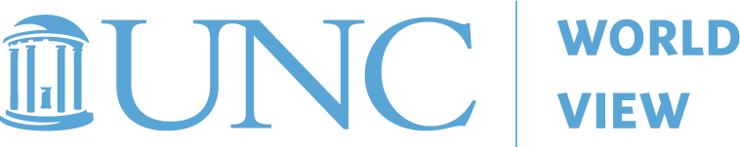Study Guide
world view 2019 K-12 global education symposium
The Sustainable Development Goals:
Classroom Connections
October 16-17, 2019
The Friday Conference Center, Chapel Hill, N.C.
Name: | School:
Position: | City or County:
Content area (if applicable): | Grade Level (if applicable):
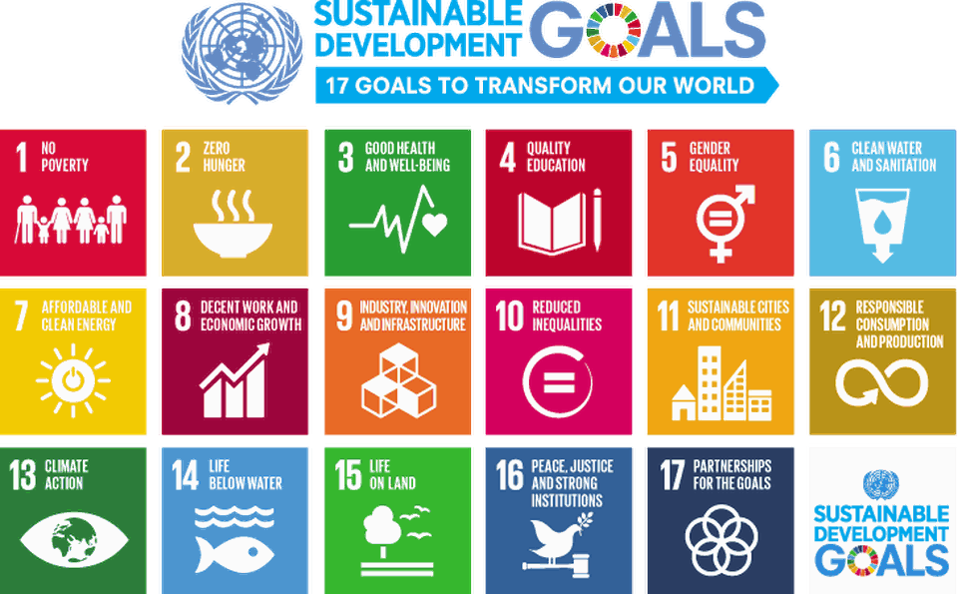
The Sustainable Development Goals (SDGs) are 17 goals that create a roadmap to improve the overall well-being of the world’s population by having objectives that cut across economic, social and environmental dimensions. The objectives include the elimination of poverty, gender equality, improved global health and fighting climate change, among other things. The SDGs, often referred to as the Global Goals were ratified by the United Nations and its 193-member countries in 2015.
Instructions: To receive 1.5 CEU credits you must attend all symposium sessions and turn in your completed study guide. Please return your completed study guide by Friday, November 1, 2019. You may email, fax or mail this completed document.
Email: kinnaird@unc.edu
Fax: 919/962-6794
Mail: World View, CB 8011, UNC-Chapel Hill, Chapel Hill, NC 27599-8011

Readings:
- Sustainable Development Solutions Network (SDSN). Chapter 1: Getting to know the Sustainable Development Goals in Getting Started with the Sustainable Development Goals, A Guide for Stakeholders. December 2015. Available at: https://sdg.guide/chapter-1-getting-to-know-the-sustainable-development-goals-e05b9d17801

- Lee, Jenni. 6 Reasons to Keep Pushing on the Sustainable Development Goals. United Nations Foundation Blog. Published July 9, 2019. Available at: https://unfoundation.org/blog/post/6-reasons-to-keep-pushing-on-the-sustainable-development-goals

- PLEASE ANSWER THE FOLLOWING QUESTIONS BEFORE ATTENDING THE
OCTOBER 16-17, 2019 SYMPOSIUM:

- What does the UN and its member countries hope to accomplish with implementing the Sustainable Development Goals? Do the Global Goals matter to you and your students? Why or why not?

- The SDGs were developed, in part, using lessons learned from its predecessor, the Millennium Development Goals (MDGs). What are three differences between the SDGs and the MDGs?

- Review the icon list of 17 Global Goals located in Chapter 1: Getting to Know the Sustainable Development Goals (For additional information on each Goal – visit https://sustainabledevelopment.un.org/sdgs.) Choose three goals that you feel are particularly critical in the global context and explain why. Additionally, reflect on the community that you serve as an educator. In your opinion, what goal or goals do you think your community might identify as areas of critical focus within the local community? Explain why.

- PLEASE ANSWER THE FOLLOWING QUESTIONS AFTER ATTENDING THE
OCTOBER 16-17, 2019 SYMPOSIUM:

- What are one or two ways you might be able to specifically connect the Sustainable Development Goals to your work as an educator?

- Did you gain any new knowledge, strategies or resources from the Symposium that you will share with peers or integrate into instruction in sophisticated ways? If so, what was it or what were they?

