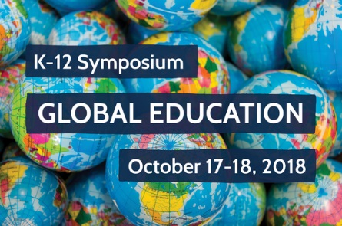
world view 2018 K-12 Global Education Sympsoium
Study Guide
October 17-18, 2018 The Friday Conference Center, Chapel Hill, N.C.
Name: | School Name:
Position: | City or County:
Content area (if applicable): | Grade Level (if applicable):
Instructions: To receive 1.5 CEU credits you must attend all symposium sessions and turn in your completed study guide. (Up to 1.0 of those are DLC-aligned) Please note there is a final question to answer after attending the symposium on October 17-18. Please return your completed study guide, along with the conference session tracking form, by Monday, November 19, 2018. You may email, fax or mail the completed documents.
Email: bradys@unc.edu
Fax: 919/962-6794
Mail: World View, CB 8011, UNC-Chapel Hill, Chapel Hill, NC 27599-8011
Preparatory Materials:

- Rosling, Hans and Ola. “How Not To Be Ignorant About the World”. TED. June 2014. Lecture.
(**Be sure to respond to #1 before viewing the Ted talk.) https://www.ted.com/talks/hans_and_ola_rosling_how_not_to_be_ignorant_about_the_world
- News Lit Quiz. (n.d.). Retrieved from https://newslit.org/get-smart/news-lit-quiz/
- Brown, Stephanie Willen. Credible or Clickbait: News Stories or Schema of Fake News to Corrections. Communication Journalism Education Today. Spring 2018. https://cdr.lib.unc.edu/indexablecontent/uuid:c090bac4-64a9-46fa-953d-ecaec4e9b00d Accessed September 18, 2018.
- What is Global Competence (n.d.) Retrieved https://asiasociety.org/education/what-global-competence

- Before viewing the Ted talk, How Not to Be Ignorant About the World, make an educated guess in answering the following questions:

How did the number of deaths per year from natural disasters change in the last century?
- More than doubled B. Remained about the same C. Decreased to less than half

Women aged 30 spent how many years in school? (men of same age spent 8 years)
- 7 years B. 5 years C. 3 years

In the last 20 years, the percent of people living in extreme poverty has…?
- Almost doubled B. Remained about the same C. Almost halved

- View the TED talk, How Not To be Ignorant About the World.” Check your answers to the above questions. What do you think Hans Rosling meant when he said, “to think about the future you have to know about the present?”

- What do the Roslings suggest might account for general public ignorance around issues such as these and what solutions do they propose?

(continue to #4-6)

- Test your own news literacy. Click on this link: https://newslit.org/get-smart/news-lit-quiz/ to access the How News Literate Are You? quiz from the News Literacy Project. After taking the quiz, please share some of your observations about the quiz or your own assessment results. Were you surprised by anything you read or learned? Why or why not?

- As educators and students increasingly interact with diverse and complex forms of media, it is increasingly vital that both educators and students develop their media literacy skillsets.
  - Identify 2-3 strategies described in Stephanie Willen Brown’s article, Credible or Clickbait: News Stories or Schema of Fake News to Corrections, that you might incorporate into your personal analysis of media or your educational practice.

  - Why might these types of skills be important in developing globally competent students in the 21st century? For a refresher on what global competence is, explore this resource from the Asia Society: https://asiasociety.org/education/what-global-competence

After the Symposium:
- Please share one goal identified in your action planning or team meeting. How will you work to globalize or further globalize your classroom, school or district? Was there anything in particular you learned during the Symposium that will support this goal? Explain.

