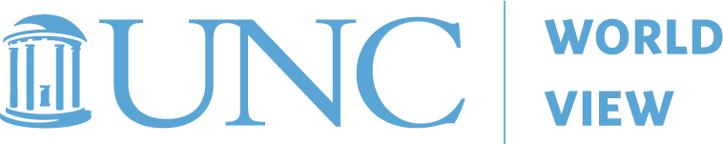

UNC world view 2020 COMMUNITY COLLEGE VIRTUAL FALL PROGRAM
STUDY GUIDE for pDCH

gLOBAL HEALTH: THE CHANGING PROGNOSIS
nOV. 5TH AND 6TH

Name: | College Name:
Position: | City or County:
Instructions: To receive 5 Professional Development Contact Hours (PDCH) you must attend all sessions of this two-part program and turn in the following completed study guide via email by December 10, 2020. Please turn in the study guide to Nick Allen (nicka@unc.edu).

Video:
TED Talk: It’s Time to Bring Global Health Home
Description: When Anne Sosin returned home to the United States after nearly a decade working on health issues abroad, she discovered a shocking decline in the health of poor American communities. While the health of some of the world’s poorest countries had improved, life expectancy in the US fell in 2015 for the first time since the height of the HIV/AIDS crisis. In this talk, Anne explores insights global health offers to address the growing health disparities in the US and the social inequities that underlie them. More importantly, she tells us why the global health community should care about the health of poor US communities.
https://www.youtube.com/watch?v=6qpaQ05VklE

Readings:
Stepping on the Gas: Community Colleges as Engines of Economic Mobility: Retrieved from:
https://www.mobilitypartnership.org/stepping-gas-community-colleges-engines-economic-mobility

Colleges Are No Match for American Poverty: https://www.theatlantic.com/education/archive/2018/05/college-poor-students/560972/

TED Talk: It’s Time to Bring Global Health Home
- What are your overall reactions to the talk?
- What points or arguments did you agree or disagree with and why? What points would you want to learn more about?
- What connections did you make between Anne’s talk and the current COVID-19 pandemic facing the United States and the world today?

Readings: Rethinking the Future of Global Health
Gubta, V. (2020) Rethinking the Future of Global Health. Retrieved from https://www.thinkglobalhealth.org/article/rethinking-future-global-health

Questions:

- From your perspective, what were three takeaway messages from the article Rethinking the Future of Global Health?
- Based on information presented in the article, do you believe global health will change for the better and become more inclusive? Why or why not?
- In what ways do you believe the evolving nature of global health will change education in the United States and beyond?

Readings: Manual for Developing Intercultural Competence
Deardorff, Darla K. (2019). Manual for Developing Intercultural Competencies: Story Circles. (UNESCO/Routledge) Available here: https://www.taylorfrancis.com/books/9780429244612
Please read pages 1 – 11 (Background), pages 13 – 59 (Story Circles), page 70 (UNESCO Story Circles Information Sheet) and page 71 (General handout).

- Many employers are highlighting the importance of hiring graduates with intercultural competence skills. Based on the information in the manual, in what ways can you work to increase intercultural competence among students at your institution?
- How would you go about advocating for the use of this methodology at your institution? What are the advantages and disadvantages of using this methodology?
- What skill sets are being acquired and developed by students through the practice of Story Circles? As an educator, how could you continue to foster these skills among your students?

