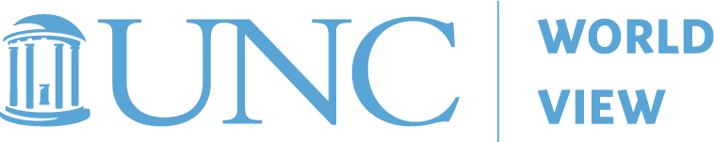
world view 2020 K-12 VIRTUAL FALL PROGRAM
STUDY GUIDE for CEU
Shared Narratives:
UNESCO Intercultural Competency Training
October 8, 2020
Name: | Email:
Position: | School and City or County:
Content area (if applicable): | Grade Level (if applicable):
Instructions: To receive .5 CEU credits you must attend the virtual program on October 8th and turn in this study guide completed. Please return completed study guide by Friday, October 30, 2020 to Nick Allen, World View Program Coordinator at nicka@unc.edu.

Reading:
Deardorff, Darla K. (2019). Manual for Developing Intercultural Competencies: Story Circles. (UNESCO/Routledge) Available here: https://www.taylorfrancis.com/books/9780429244612
Please read pages 1 – 11 (Background), pages 13 – 59 (Story Circles), page 70 (UNESCO Story Circles Information Sheet) and page 71 (General handout).
Video:
National Education Association. (April 2010). Cultural Competence: What Does It Mean for Educators? Available here: https://www.youtube.com/watch?v=U42MApeXi9w

- PLEASE ANSWER THE FOLLOWING QUESTIONS BEFORE ATTENDING THE OCTOBER 8th VIRTUAL PROGRAM.

- In the short NEA video Cultural Competence: What Does It Mean for Educators? we hear from several education experts on what cultural competence means to the them and why it’s important. In your own words what is cultural competence to you?

- Dr. Deardorff’s Manual for Developing Intercultural Competencies: Story Circles looks at specifics for developing intercultural competencies in individuals. “To summarize many existing definitions, intercultural competencies in essence are about improving human interactions across difference, whether within a society (differences due to age, gender, religion, socio-economic status, political affiliation, ethnicity, and so on) or across borders” (page 5). How can you, your educational environment or community benefit from increasing intercultural competencies among its members?

- What are some of the greatest benefits of the Story Circles methodology? Are there any challenges with using this methodology?

- What skills are being acquired or developed through the practice of Story Circles?

- How is “listening for understanding” different than just “listening” and why is “listening for understanding” crucial to the success of the Story Circles methodology?

- PLEASE ANSWER THE FOLLOWING QUESTIONS AFTER ATTENDING THE OCTOBER 8th VIRTUAL PROGRAM.

- Did you gain any new knowledge, strategies or resources by participating in the October 8th program?

- Do you think you can implement Story Circles in your educational environment? If so, please share three action steps you will take to make it happen. Include the prompts you would use if known.

- What additional formal, in-formal, or non-formal opportunities (including virtual opportunities) can you engage in to develop intercultural competencies including practicing deep listening, increasing one’s own cultural self-awareness and awareness of others, connecting across difference in a respectful manner, developing empathy and discovering similarities, especially with those who seem quite different? Please list a few ideas you’d like to explore or try out in the upcoming year.

