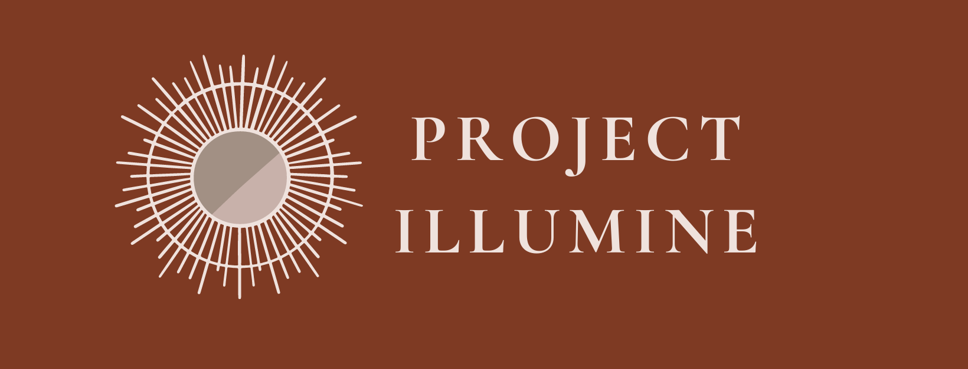
By Susan O’Rourke, PhD Candidate
Dept. of English and Comparative Literature
UNC-Chapel Hill

Early Modern Irish Women’s History and Writing
Why teach early modern Irish women’s history and writing?
Irish history and literature are already important parts of many curricula. Given the immigration of an estimated 4.5 million Irish people into the United States between 1820 and 1930, Irish history is frequently taught in history classrooms (and was recently mentioned in North Carolina’s Essential Standards). Irish immigration serves as an excellent case study that challenges students to think critically about the economic, social, and political factors that spur on immigration; the history of nativism; as well as national identity and heritage.
Yet, Irish history is more fraught than many students realize. The country was colonized by England in the early modern era, which created a fractured sense of national identity and excluded the largely Catholic Gaelic Irish and Old English from civic and economic life. By studying early modern Irish history and literature that came out of that period, educators can offer an additional lens through which students can understand colonialism and analyze its impacts on national identity and cultural heritage. This history is especially important given the long-term impact of colonial-era laws. In Northern Ireland, for example, the Ulster Plantation of the early 17th century which dispossessed the native continues to shape the political landscape of Northern Ireland.
Additionally, by studying Irish poetry, educators will be better equipped to push back on the traditional exclusion of early Irish literature from classes on literature in English. Educators in the United States will not have to wait until the 19th and 20th centuries arrive to bring Irish authors (like James Joyce, Oscar Wilde, Samuel Beckett, and William Butler Yeats) into their classrooms—and even then still wait to meet Irish women writers. This unit will help educators in the United States counter that truncated understanding of Irish women’s writing. This unit will help bridge the gap between scholarship on early women writers in Ireland and classrooms.
So, let’s set our intellectual ships asail on the Muir Éireann (the Irish Sea) and travel to meet Caitilín Dubh, an Irish poet and our guide into the literary traditions and fraught political landscape of 16th-century Ireland.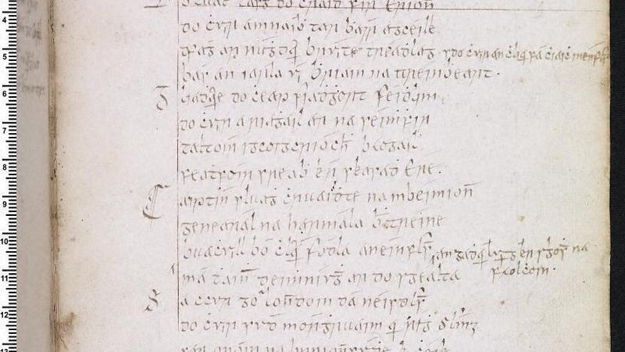
Excerpt from one of Black Caitlin 's poems. Image courtesy of Russell Library at Maynooth University and Irish Script on Screen

Poetry of Bards and the Bereaved
While we do not know much about the origins of Caitilín Dubh (pronounced Duv, meaning “Dark-Haired”), her writings indicate that she was a poet associated with the O’Brien family of the small kingdom of Thormond, now known as County Limerick, in the Mid-West Region of Ireland. What do we mean by a poet’s family association? Let’s first take a look back at the role of bardic poets more broadly.
Early Ireland was a structured society, and poets traditionally occupied positions of prestige and power within the courts of noble families. The prestige stemmed from their intensive training—they trained for years at specialized bardic schools to learn a very precise poetic form, memorize poems, and develop their individual voices; their power reflected their dual roles as interpreters of political and social events and historians who commemorated in verse the deeds (and misdeeds!) of the noble family and local community. Their roles were even codified in Brehon (Irish) Law (pronounced BRAY-hone Law) until the English colonized Ireland, cast Brehon Law aside in 1603 and supplanted it with English law. Before that date, specific classes (with resulting privileges) were assigned to poets, including the prestigious group that wove together poetry, law, and history, called the filídh (FILL-ah, singular filí). The most prestigious and highly trained poets, the ollamh (UH-liv), were even more powerful than some nobility. Yet the power held by these poets lay not only in the esteem afforded by their mastery of poetic forms, but also in their social role within Irish courtly culture. Sarah McKibben explains that “Bardic patronistic verse in syllabic meters was for more than a thousand years a crucial form of cultural currency across Gaelic Ireland and Scotland” as it was recognized not only for its literary merit, but also “ as validation and proclamation of the authority, genealogy, wealth, and prestige of those in power, commemoration of events and goods of significance to their patrons; they also inscribed counsel on questions of diplomacy, decorum, and protocol, highly attuned as they were to shifting balances of power.” Coolahan likewise explains that the fileadha recorded historical events (recording “heroism, military valour and leadership”), crafted the character of their patrons (noting “noble descent and genealogy [....], physical prowess and beauty”), and (perhaps unexpectedly to contemporary readers), could “satirize and declaim” their patrons in order to push them to care for the needs of their people. Upon the death of a leader, bardic poets composed elegies recalling the deceased’s esteemed qualities and accomplishments and lamenting the impact of their absence from the community.
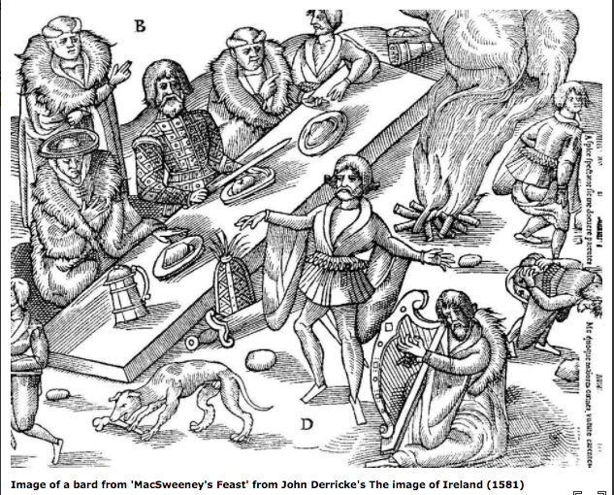
“Image of a bard from ‘MacSweeney’s Feast’ from John Derricke’s The image of Ireland (1581)”

Were there female poets?
While less common, women in Ireland certainly wrote poetry and were involved in the cultural production of poetry! Historians note that records show evidence of an Irish female poet living as early as 900 A.D. This woman whose name is recorded as Iníon Uí Dushláine (ih-NE-in oh de-LAY-ney, meaning “Daughter of Delaney”), was a bainletcherd (where bain is a form of the Irish word for woman, bean, and letcherd refers to a poet’s rank, like the aforementioned ollamh). The records indicated that this “Daughter of Delaney” had achieved the second highest rank and had even “set out on her poetic “‘cuairt,’ a kind of Grand Tour that poets used to make.” No small feat!
But that’s just one woman…
Importantly, there was not just one, singular, exceptional female poet in medieval and early modern Ireland. Fictional texts and records refer to other female poets referenced in records including “Brighid iníon Iustáin (BRI-gid in-EE-in oo-STIN), Liadán ben Chuirthir (LE-ah-dun ben QWEER-thur), and Uallach iníon Mhuineacháin (UL-luck in-EE-in MWEE-ne-han). While opportunities for women to train as poets were quite curtailed by the 17th century, when we meet back with Caitilín Dubh, women still found opportunities to participate in the Irish cultural production through poetry and the practice of keening (more on keening in a moment). Scholars have established that, among the many poets that lived and worked in Ireland’s kingdoms, there existed a class of poets “who lacked formal schooling in poetry but whose compositions might still be highly regarded,” and that women found a home in this informal but respected poetic tradition. Women’s leadership in the cultural practice of keening further granted them cultural respect and authority.
What is keening?
Keening was a formal and often poetic tradition that facilitated communal mourning and spiritual passing. Keening, in contrast to bardic poetry in the 17th century, was guided by the mna chaointe (ma-NAW HOINT-a), or professional keening women. Historians explain that these performances were full of emotion and carried spiritual power, as the verses, melodies, and cries of the keening women were thought to help facilitate the transition from living to the afterlife and guide the community through this loss. During the keen, women would sing poems, refer back to the deceased’s family history, and recall the lived experiences of the deceased. The keeners did so by invoking the spirit of the bean sí (known today as “banshee”).
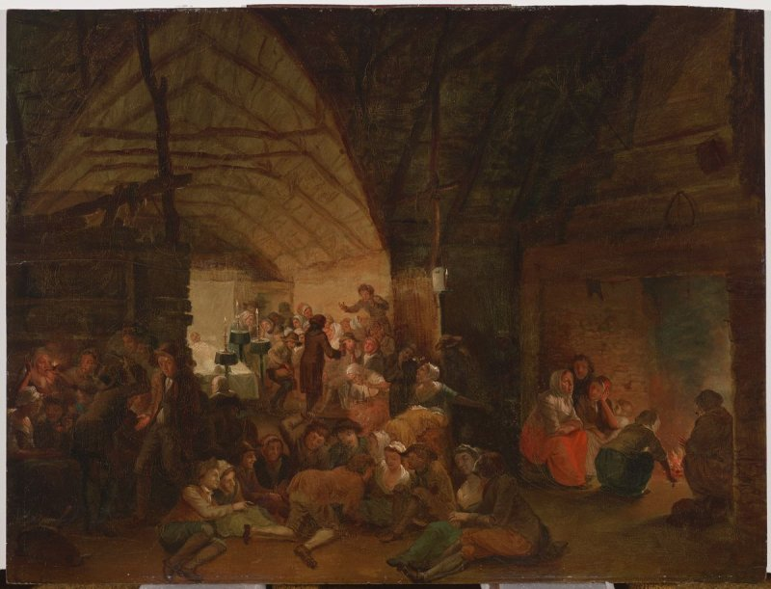
Irish painter Nathaniel Grogan’s The Wake (early 19th century)
What a bean sí is and isn’t:
People often associate often associate “banshees” with contemporary popular depictions ranging from the flying dragons, or “Mountain banshees,” in James Cameron’s film Avatar to the demonic figures in horror films like Banshee Chapter. While the early Irish bean sí might have evoked some fear since it was associated with death, these spirits were not just simply spooky figures. A bean sí as deeply connected with individual families and reflected women’s power rooted in customs related to death and spirituality. The early Irish bean sí was a female spirit—sometimes described as a frail old woman or as a young woman—who was (spiritually) attached to a family or region and whom people (most often family members) detected—either through a visual sighting or by hearing the bean sí wail—before or at the time of a family member’s death. Their cries preceded the subsequent mourning orchestrated by female keeners. Notably, while its cries were seen as ominous, the bean sí were not responsible for a person’s death. In fact, historians note, a bean sí could be seen as “territorial goddess,” as was Aoibheall, “the famous bean sí of County Clare.” These female spirits were believed to remain with families through generations, giving them a sense of spiritual authority.
Fusing Gendered Poetic Traditions
Caitilín Dubh’s elegies provide insight into the remarkable weaving of the male bardic tradition with that of the female-gendered caeoineadh (the keen sung by female mourners). Let’s first now read Dubh’s poem, paying attention to Dubh’s description of the bean sí Aoibheall, explanation of how she compares with Aoibheall, and the information she relates about Diarmaid Ó Briain (DER-mid O’Brian).

Caitilín Dubh composed this for Diarmaid Ó Briain, the Baron.
Once, when I was dejected and joyless,
gazing at the gull-filled cool bright harbor,
as stormy waves hit the land
and grief laden voices were heard,

and as the evening birds released their cries,
casting an eye about me
I saw Aoibheall approach me wearily,
the gentle, ancient fairy woman.

She sat next to me and addressed me gently
and enquired of me in these words:
‘O, God, was any woman ever like me,
traversing wind-swept mountains,

‘beating my palms and marrying my looks
in thick woods where no one shelters me,
crossing streams boatless and directionless?’
I replied to her truthfully,

saying she was seven times better off than I was
since sorrow has broken my heart,
I have lost my vigour, I cannot walk,
I do not distinguish day from night,

For Ireland has been worsted,
she has lost her balance, it is no good to mourn for her,
she is broken, sick and weak in body
after that band of the great line Míle.

Béibhionn of the heavy ringlets said:
‘Do not heed them, it is not right to keen them,
an old saying written by Cato has it
that there is no sunshine without a weather-change.

‘Sadness follows every joy,
the ebb follows the full tide,
so this land is in the wake of the royal sons.’
The great-hosted earl of lordly deeds,

and the Baron of encouraging words—
the son of Ó Briain^{[38]} to whom thousands submitted,
and Diarmaid—have enslaved men to sorrow
and have sent a pang through the ribs to their hearts.

A man ever praised has plunged people into sorrow,
guiding light of the poor, the flower of princes,
the potion of forgetfulness bestowed on us by kings
the paragon of knowledge for the youth of the line of Míle.

Support of the men of art of Inishloe,
you were the one hope for your class in the eyes of the church,
a pupil and a very Manannán to the poets,
an affable scion of the descent of kings,

A jewel of diamond most precious,
sweet melody of ladies and their strength.
Many the foolish harlot keens for you
as does the gambler, threadbare from throwing the dice;

white-fingered ladies are abandoning their coiffed hair
and every day their eyes flow for you,
elderly matrons are in bitter, wasting misery,
bards have become soft-spoken and subdued.

Every clerk who was wont to read the Bible
cannot now distinguish one letter of it,
since your death woods have declined
fish in streams no longer rend the nets.

The sleek deer does not leap across the pathway,
the long snouted hound does not run in pursuit,
the stars no longer rise by night,
the ethereal skies are a quaking mass

since your death, O hand that dispensed charity,
who did not snub men of art in distributing wealth,
who did not covet worldly goods,
who did not cause any man to despise his wife,

but who loved the good and who met miserliness with excess,
who loved no woman beyond the rights of her lover,
who could not be bribed in order to pervert a judgement,
who did not deny the weak their ancestral rights,

but who took delight in welcoming the old and in doing good.
Bravo the nobleman of the sons of Míle,
of the line of Cas who was not soft with enemies,
of Éibhear and Féidhlim son of Críomhthann,

of Cormac mac Airt who fought the Battle of Mídhe,
of Gerald the Greek,^{[47]} of Niall the devout
and of mighty Fearghus^{[49]} who defended in the island.
If Christ has taken you in retribution

for the arrogance of those warriors
and has placed a tombstone over you,
that has caused such a pain in the hearts of warriors
that a strengthless woman could bind them.
The tidings have spread throughout the land,
woe is me! – they must be told.

Caitilín Dubh’s poetic laments makes clear the emotional devastation O’Brian’s death brings to his people. She speaks of the sadness flowing throughout the land, affecting men and women from all backgrounds, from “foolish harlot[s]” to “white-fingered ladies” and elderly women, and from “clerk[s]” to devoted Bible readers to “gambler[s].” The baron’s death even disrupts the order of nature as
The sleek deer does not leap across the pathway,
the long snouted hound does not run in pursuit,
the stars no longer rise by night,
the ethereal skies are a quaking mass.

The poetry of loss and mourning in which Caitilín Dubh aligns herself with the bean si (“you have made an Aoibheall of me in your wake,/or a bean si frequenting every fair hillside”) fuses with the bardic tradition as Caitilín Dubh moves into “established bardic topics—geneaology, military valour, patronage, and hospitality.” She recounts:
Bravo the nobleman of the sons of Míle,
of the line of Cas^{[42]} who was not soft with enemies,
of Éibhear^{[43]} and Féidhlim son of Críomhthann,^{[44]}

of Cormac mac Airt^{[45]} who fought the Battle of Mídhe,^{[46]}
of Gerald the Greek,^{[47]} of Niall the devout^{[48]}
and of mighty Fearghus^{[49]} who defended in the island.

Dubh’s poem thus presents a fusion of traditions that elevated the feminized custom of keening and demonstrates her creative poetic prowess.
The Personal Is Political: Caitilín Dubh’s Poetry Confronts Colonialism
Caitilín Dubh’s poetry further provides insight into
- early modern political tensions in Ireland as English forces colonized the country,
- the mixture of English and Irish political allegiances that formed in response,
- changing senses of national identity as New English and Irish communities came into contact, and
- the seepage of these concerns into Irish literary canon.
To better understand the political tensions and complicated sense of Irish identity in her poetry, we will first take a look back the English conquest and colonization of Ireland.
English Colonial Conflict: Irish Edition
The systematic campaign by the English to colonize Ireland and dispossess the Irish ramped up in the early 16th century. The colonization process has a complex history and entailed different policies and campaigns under leaders including King Henry VIII, Queen Elizabeth I, James I, and Oliver Cromwell. Efforts to colonize Ireland in the 16th and 17th centuries included
- military campaigns to invade Ireland and seize land
- legal policies that stripped Irish landowners of their property rights or encouraged Irish landowners to give up their property rights
- incentives for the English to take ownership of Irish lands (policies which the English politely termed “settling” and “planting” Ireland)
- the replacement of Brehon law with British rule
- the establishment of Protestantism as the official religion and suppression of Catholicism
The English conquest brought into focus different ideas over national identity and created competing allegiances. At the time of the English colonizing efforts, there were considered to be roughly four distinct identities held by people living in Ireland:
- The “Native” or Gaelic Irish: The Gaelic Irish were those whose ancestors arrived in Ireland thousands of years before the early modern period and were largely Catholic.
- The Old English: The Old English were descendants of invading Anglo-Normans who were mostly Catholic, learned Irish, and integrated into the Gaelic Irish population through marriage.
- The New English: The colonizing class that was supported by the English Crown, curtailed Irish political and economic power, and suppressed expressions of Gaelic culture (including language)
- The Ulster Scots: Another part of the colonizing class supported by the English Crown that settled in Northern Ireland (Ulster)
As the colonizing groups asserted political power in Ireland, Gaelic Irish and Old English leaders and citizens had to determine the degree to which they would resist English rule or try to negotiate with the colonizers.
Caitilín Dubh’s Poetry: Fusing Identities and Allegiances
Caitilín Dubh’s poetry, scholars note, reflects her awareness of the strain on political leaders and showcases for us the seepage of the English rule in Ireland into the Irish poetic canon. Her poem to Donnchadh (DON-ah-huh), fourth earl of Thomond, in fact, “demonstrates an elasticity in composing Gaelic verse which was prepared to accommodate cooperation with the English crown in order to preserve literary culture.” Let’s take a look:
Caitilín Dubh composed this on the death of Donnchadh, the Earl of Thomond.

I have heard tidings that have tormented the men of Ireland,
that have deranged their womenfolk,
that have left their authors bruised and debilitated,
the poetic community in gloom—
this is the death of the Earl Ó Briain of great deeds;

a warrior who checked the wild Land of Feidhlim,^{[1]}
imposing his rule upon her nobles,
a raider in dangerous territories,
a watcher of rivers who encompassed Ireland,

the blow-striking captain hardened through encounters with hosts,
an army general most powerful,
guardian of the whole land of Fódla,
the tracker dog by whom the wolves were extirpated.
If these tidings of you have been confirmed

And have gone to be heard in London,
then King James^{[2]} has suffered great dejection
as have the honourable princes,
dukes and powerful magistrates.

His secret loves and countesses are crying bitterly
as are those, adorned in gowns, in whose
presence voices were wont to be lowered.
Your death is a ruinous loss to young and old,

To the foreigners and to the Irish,
and the Plain of Cobhthach is despoiled through your death,
soothing sleep is not enjoyed, no poem is listened to,
music, festiveness and feasting are neglected,

rough fighting men are not engaged to perform heroic feats,
steeds are not bestowed, poetry is unloved,
boats in numbers no longer ply to shore
in the wake of your death which has tormented all.
Since Conn initiated the hundred battles,
since Cairbre^{[5]} was killed in the battle of the blows,
since Éoghan Mór was killed in the battle of Magh Léana
and since the other Éoghan fell to Béinne,

since Brian and Murchadh fell together in battle,
no death, it seems, exceeds your demise,
scion who provoked the whole of Ireland,
who visited sword and fire forcefully on Ulster,

who went to Donegal in order to destroy it
and to Dungannon, a vigorous move,
to Assaroe beating your shield,
to Strabane and nearby the River Erne.

Donnchad Ó Briain proved himself to be a leader
when his fighting bands stormed beside him,
with his artillerymen shouting out to one another
and his battle standards blowing and bouncing off their poles.

In Bealach an Díthrimh you performed a feat,
you left Mac Uilliam incapacitated
when you severed both leg and spur together
and Fermanagh you forcefully burned,

buildings and meadows together, in like manner
and Cavan in bright daylight;
you were not content to allow the Lord of Sligo escape you
nor Ó Ruairc though he was closely related to you.

The chief of Moylurg you made a prisoner of
you destroyed Ó Conchubhair,
all the provinces were under your control,
and thence to Tír Briúin of the English.

The men of Meath came under your protection
and the Leinstermen delivered up to you their own hostages.
Why should I enumerate these
since, into every town and highway and moor,

knowledge of the standards of this champion had reached?
You spent a long day in the mouth of the Bandon River^{[17]} fighting
And from there you went to the west of Beare.

Though Don Juan had sufficient military strength
he was forced to surrender to you meekly;
he gave an oath and his word
that, if you allowed him to return in dire straits to Spain,

he would never show his face to you again in Ireland,
He did well in this for he was in great danger
As you put your defence works against him
And placedyour eager soldiers on his every side.

When the Lord Deputy was minded to raise the siege
you encamped your forces in one place.
Well was the land of Cian smoothed over for you,
O son of the kings descended from Tál to whom Ireland was given.

I shall again take up the story of your ancestry:
you are of the line of the House of Austria,
a kinsman of the battle-inured king in London
and of the stately king of mighty Spain,

of the king of Poland, whose crown was not brought low
and of the king of the French, so stout in his demands.
Kinsman of the noble king of Bohemia,
of Charlemagne and of Caesar,

and of Paris who fought the prolonged battle in Troy,
of the emperor who started the feast
and who gave the kings of the entire world to each other.
Kinsman of every other exalted noble.

if death has claimed you as part of his fee
Banba is now without a spouse,
her visage has altered,
she has put on a black in place of a bright countenance.

She is blind, she hears not,
she is lame and incapacitated
in the wake of him with whom she made union,
your separation from each other is pitiful and harsh.

I have heard tidings that have tormented the men of Ireland.

In her elegy to Donnchadh, fourth earl of Thomond, Dubh first hints at the interwoven connections between Gaelic Irish, New English, and the English Crown as she emphasizes a vast political network that grieves the earl’s death. She suggests that:
If these tidings of [his death] have been confirmed
And have gone to be heard in London,
then King James has suffered great dejection
as have the honourable princes,
dukes and powerful magistrates.
…
Your death is a ruinous loss to young and old,
To the foreigners and to the Irish[.]

She elevates Donnchadh by highlighting the extensive grief felt by Irish and English, alike. The sorrow the English Crown feels over Donnchadh’s death further gives respectability to his alliance with the English. She stresses that he mattered to the Crown. Historians emphasize that Caitilín Dubh also smooths over the fact that he sided with the English during the conquest by navigating “an elaborate genealogy” that suggests that Donnchadh is not only Gaelic Irish; he is a man with a complex and noble heritage that reaches back even to the mythic level. Donnchadh is:
of the line of the House of Austria,
a kinsman of the battle-inured king in London
and of the stately king of mighty Spain,

of the king of Poland, whose crown was not brought low
and of the king of the French, so stout in his demands.
Kinsman of the noble king of Bohemia,
of Charlemagne and of Caesar,

and of Paris who fought the prolonged battle in Troy,
of the emperor who started the feast
and who gave the kings of the entire world to each other.
Kinsman of every other exalted noble.

With each genealogical connection drawn, Dubh makes sure to align Donnchadh with the king of most countries, including England. This genealogy “[could have directed] [Dubh’s] audience toward multiple continental connections and away from the binary opposition of Gaelic-English” and established a line of kindship that more easily justify the earl’s willingness to partner with the English forces occupying Ireland. The poem raises important questions about how leaders and citizens navigate political and cultural survival in the face of oppression.
Conclusion: Irish Literature’s Place in the English-Language Literary Canon and English Literature Coursework
While the bean si in Caitilin Dubh’s elegy laments the loss of Diarmid, Baron Inchiquin, this sense of loss and imbalance has also characterized the status of early Irish literature, particularly that written by women, in literary studies until recently. While feminist recovery work successfully illuminated the work of early modern women writing literature and about politics, the sciences, and philosophy, scholars have more recently sought to recover the experiences of women whose lives and cultures were altered and, at times, suppressed by the British colonial project.
This decentralization does not ignore England’s rich literary history but rather asks scholars, educators, and students to see the complexities of literature, culture, and identity in a region that includes Ireland, Scotland, and Wales. Project Illumine thus helps educators introduce students to an “‘archipelagic’” perspective by investigating those countries’ cultural histories and questioning the hierarchies existing in literary studies. After inviting students to set their intellectual boats ashore on the Irish coast, we hope that they will sail onward with increased cultural curiosity toward new destinations.

The Library of Congress, “Irish-Catholic Immigration to America,” web page, The Library of Congress, accessed February 11, 2022, https://www.loc.gov/classroom-materials/immigration/irish/irish-catholic-immigration-to-america/.
See for example: North Carolina 2019 Standards for American History I: The Founding Principles, for example, includes “Essential Standard: AH1.H3: Understand the factors that led to exploration, settlement, movement, and expansion and their impact on the United States development over time. Concept(s): Exploration, Settlement, Movement, Expansion, Diversity, Prejudice, Migration; Clarifying Objectives: AH1.H3.3 Explain the roles of various racial and ethnic groups in settlement and expansion through Reconstruction and the consequences for those groups (e.g. Germans, Scotch-Irish, Africans, American Indian Indians, Irish, Chinese, etc.)”
See the following historical account from Sean O’Hagan: The Northern Ireland Civil Rights Association (NICRA) had been formed [in 1967] before by a broad coalition – trade unionists, radical socialists, republicans and members of the Northern Irish Labour and Liberal parties – with the same basic aim: to challenge anti-Catholic discrimination in jobs and housing. One of its defining slogans was the now quaintly sexist “One man, one vote”, which demanded an end to the system of plural voting that prevailed in Northern Ireland long after it had been abolished in the rest of the UK. To be eligible to vote in a local election in Northern Ireland you had to be a homeowner, most of whom were middle- and upper-class Protestants. Many of them were business owners, which entitled them to several extra votes. To make matters worse, the state also employed gerrymandering (manipulating ward boundaries in local elections to maintain a false unionist majority). This meant that in 1968 in predominantly Catholic Derry, where the total nationalist vote was 14,000 and the unionist vote 9,000, the local council comprised 12 unionist and eight nationalist members. Since its inception in 1921, when Ireland was partitioned, Northern Ireland, though remaining part of the UK, was a place apart. One of its founders, Lord Craigavon, had promised “a Protestant parliament for a Protestant people.” Four decades later, the state was essentially and unapologetically biased in favour of its majority population in terms of the allocation of council houses and jobs.” Sean O’Hagan, “Northern Ireland’s Lost Moment: How the Peaceful Protests of ’68 Escalated into Years of Bloody Conflict,” The Observer, April 22, 2018, sec. Politics, https://www.theguardian.com/politics/2018/apr/22/lost-moment-exhibition-northern-ireland-civil-rights-1968-troubles-what-if.
Traditionally, bardic poets were “professional fileadha (‘poets’ [....]) [and] were attached to noble families and patrons. They came from “bardic schools” where they “trained [....] in the rules of literary composition, genealogy, history, saga, metres, rhymes, and literary dialect.” Coolahan notes that these poets adhered to strict forms to ensure “the prosody of Gaelic verse:” Quatrains [had] a fixed number of syllables per line, with consonants rhyming instead of vowels, Strict versification, or dan direach, demanded the highest level of skill and expertise in an array of established rules regarding metre, rhyme, assonance, consonance, [and] alliteration. See Marie-Louise Coolahan, Women, Writing, and Language in Early Modern Ireland (Oxford: Oxford University Press, 2010), 16.
Ibid.
Sarah E. McKibben, “Bardic Poetry, Masculinity, and the Politics of Homosociality,” in A Companion to Irish Literature, ed. Julia M. Wright, vol. 1 (Oxford: Wiley-Blackwell, n.d.), 59–75.
Note that these poems praised both male and female patrons.
See Marie-Louise Coolahan, Women, Writing, and Language in Early Modern Ireland (Oxford: Oxford University Press, 2010), 15-16.
Nuala Ní Dhomhnaill, “An T-Anam Mothala / The Feeling Soul : The Woman Poet in the Irish Tradition,” Études irlandaises 19, no. 1 (1994): 27–52.
Ibid., 32.
Ailbhe Darcy and David Wheatley, A History of Irish Women’s Poetry (Cambridge University Press, 2021).
Ó Crualaoich, Gearóid. 1999. The Merry Wake. In Irish Popular Culture 1650-1850. Edited by James S. Donnelly and Kerby A. Miller. Dublin and Portland: Irish Academic Press. qtd. in Mary McLaughlin, “Keening the Dead: Ancient History or a Ritual for Today?,” Religions 10, no. 4 (April 2019), http://dx.doi.org.libproxy.lib.unc.edu/10.3390/rel10040235.
Ailbhe Darcy and David Wheatley, A History of Irish Women’s Poetry (Cambridge University Press, 2021), 15.
Marie-Louise Coolahan, Women, Writing, and Language in Early Modern Ireland (Oxford: Oxford University Press, 2010), 17.
Dubh qtd. in Coolahan, 20.
Coolahan, 21.
For a more detailed historical account, we encourage reading texts like Nicholas Canny’s Making Ireland British: 1580-1650. Nicholas P. Canny, Making Ireland British, 1580-1650 (Oxford ; New York : Oxford University Press, 2001).
Marie-Louise Coolahan, Women, Writing, and Language in Early Modern Ireland (Oxford: Oxford University Press, 2010), 21.
Ibid.,, 2-15.
Ailbhe Darcy and David Wheatley, A History of Irish Women’s Poetry (Cambridge University Press, 2021), 15.
Ibid., 32.
Ibid, 28-29.
Julia A. Eckerle and Naomi McAreavey, “Introduction,” in Women’s Life Writing and Early Modern Ireland (Lincoln, Nebraska: University of Nebraska Press, 2019), 2.
Eckerle and McAreavey cite John Kerrigan as “probably the best-known proponent of [....] a ‘devolutionary approach.” Kerrigan qtd. in Julia A. Eckerle and Naomi McAreavey, “Introduction,” 3.
Julia A. Eckerle and Naomi McAreavey, “Introduction,” 2-3.
Kerrigan qtd. in Julia A. Eckerle and Naomi McAreavey, “Introduction,” 3.

